***Artificial Intelligence's Impact on Marketing***

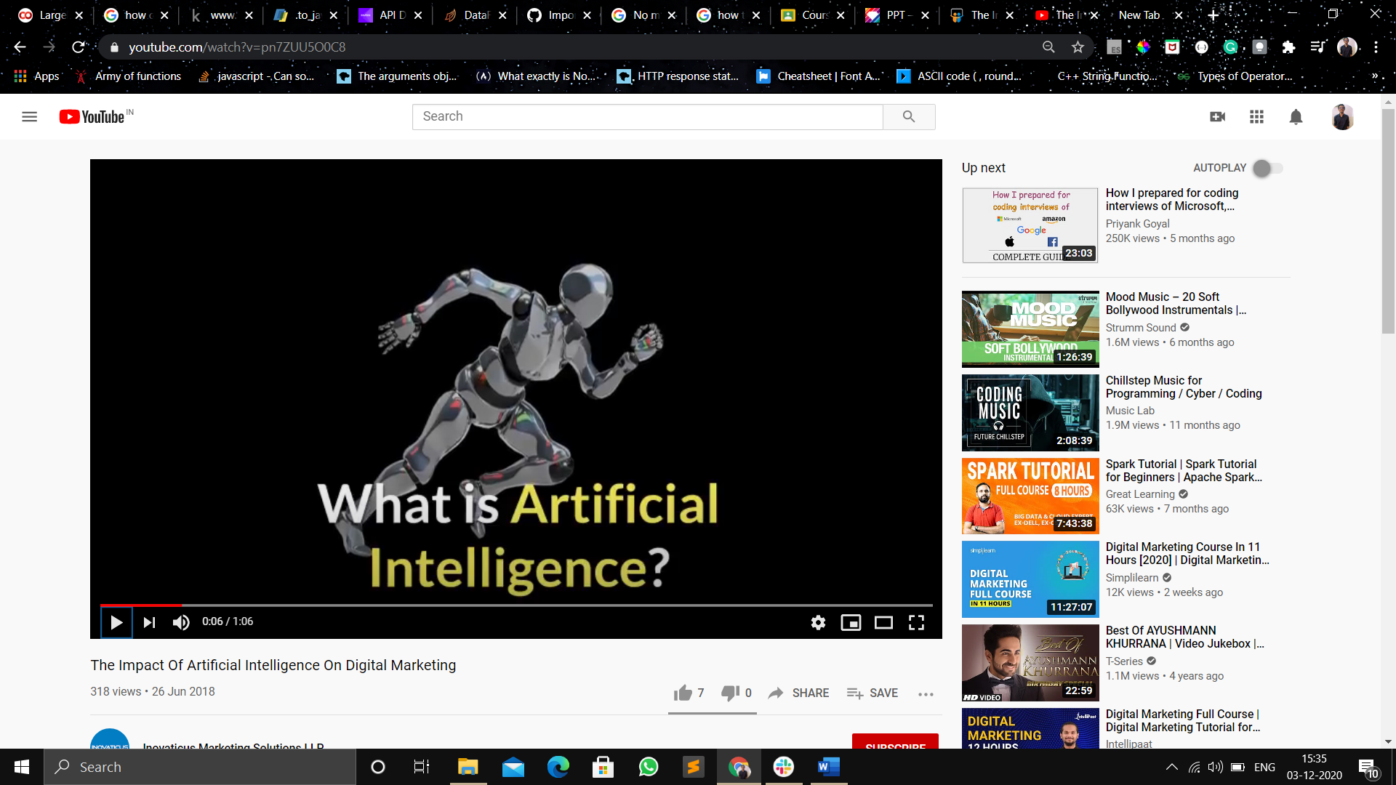

Artificial Intelligence provides machines with the ability to **analyze data** and **perform cognitive tasks**. It observes and thinks like a human to take relevant decisions, making the work of planning and execution quicker and simpler.

Although most people might argue that this will replace humans, AI actually helps them by **streamlining the process**. Once the requirements are set and the inputs are given, AI automates the whole mundane process. This ensures that humans are not burdened with any tedious work.

Or

**Intelligence demonstrated by Machine.**

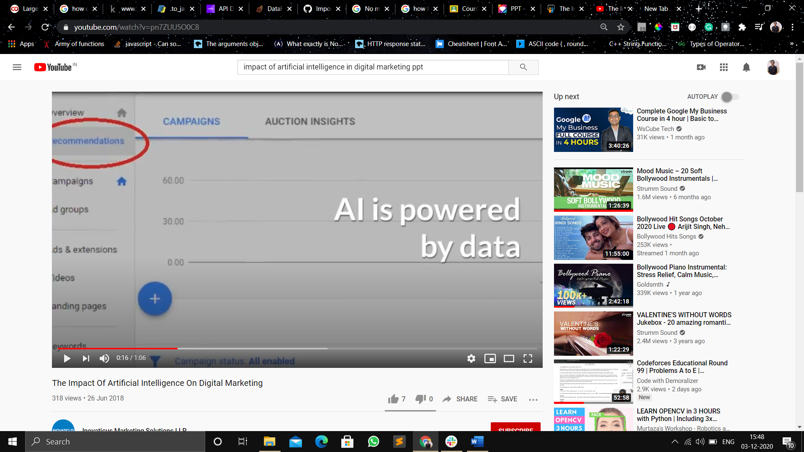

***AI is powered by data***

As mentioned earlier, the key input that machines need to become intelligent is data. Analysis of more data leads to the generation of more trends, patterns and insights. This results in Machine Learning, the outcome of which is the machines acquiring Artificial Intelligence. **The good news is that there is never a dearth of data when it comes to marketing or digital marketing**. In fact, the volume of data that is generated through digital marketing is increasing by leaps and bounds on a daily basis. On one hand, new companies are embracing digital marketing and the existing ones are also increasing their online footprints rapidly. On the other hand, with the internet coming within the reach of a large part of the world’s population, there is more data available than ever regarding their search patterns and online browsing behaviour. The volume of data that is being generated now is humongous and much more than what we used to see even a few years back. With their processing powers also increasing rapidly, the computers are gathering and analyzing information at a much faster pace now. This is resulting in faster machine learning and better and improved AI.

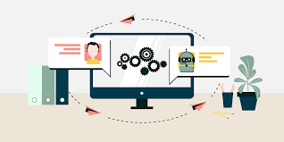

## ***What Does Machine Learning Mean for Marketers?***

In every sector, the use of machine learning and AI is on the rise, with new machine learning success stories appearing every day. According to some of American Resarchers, AI and machine learning will contribute to around [**USD 2.6 trillion in marketing and sales**](https://www.forbes.com/sites/louiscolumbus/2019/03/27/roundup-of-machine-learning-forecasts-and-market-estimates-2019/#2fcf69857695?zd_source=mta&zd_campaign=12775&zd_term=chiradeepbasumallick)by 2020!This presents an immense opportunity for marketers, especially the “early movers” in this space.

 Interestingly, marketers have proved eager for innovation, as [marketing is among the top 10 fields embracing machine learning and AI](https://www2.deloitte.com/content/dam/insights/us/articles/4780_State-of-AI-in-the-enterprise/DI_State-of-AI-in-the-enterprise-2nd-ed.pdf?zd_source=mta&zd_campaign=12775&zd_term=chiradeepbasumallick). **This is because marketers have access to massive volumes of customer data that can be converted into value-adds**, as illustrated by several machine learning examples. (Machine learning) can plumb the depths of data to contextually understand your customers and help you design scalable, hyper-personalized customer experiences. Your data repositories contain valuable insights, and combined with machine learning, they can help us in :

1. **Find customer behavior patterns{IMP Market point of view}{Google analytics}**
2. **Segment audiences into target groups**

Marketers by now know machine learning has made an impact on marketing personalization efforts

Leading companies across the world are already using machine learning as a key part of their marketing campaigns

Presence of machine learning is becoming ubiquitous, but the quality is not evenly distributed, so marketers need to know how to evaluate the potential of prebuilt AI for their specific use cases.

# *HOW MACHINE LEARNING CAN ENHANCE MARKETING?*

# 

## **Enhance Customer Experience and better search results**

Studies indicate, that 57% of major executives believe this is the area where machine learning can be most beneficial.(For Marketers)

* Guide the buying journey, making personalized product recommendations to help the customer find what they want;
* Ensure your online store never runs out of stock, or provides alternatives if stock is low; and
* Provide customers with a 24-hour support service



Way back in 2015, Google introduced its AI-powered Rank Brain algorithm. This move radically changed the way in which the search results are generated, and also changed the process of Search Engine Optimization forever. With the humongous volume of search data at its disposal, Google can use Artificial Intelligence to clearly understand and interpret the intention behind every search query. It can analyse the users past search patterns and browsing behaviours of the user to understand the exact question or problem that the user has. This will enable it to show more relevant results and the users will also get the answers that they are looking for in the least possible time. Companies can no longer occupy a particular rank on the search engine result pages for a particular keyword. Rank Brain has made the SERPs very dynamic by showing AI-powered results that will benefit the user the most.

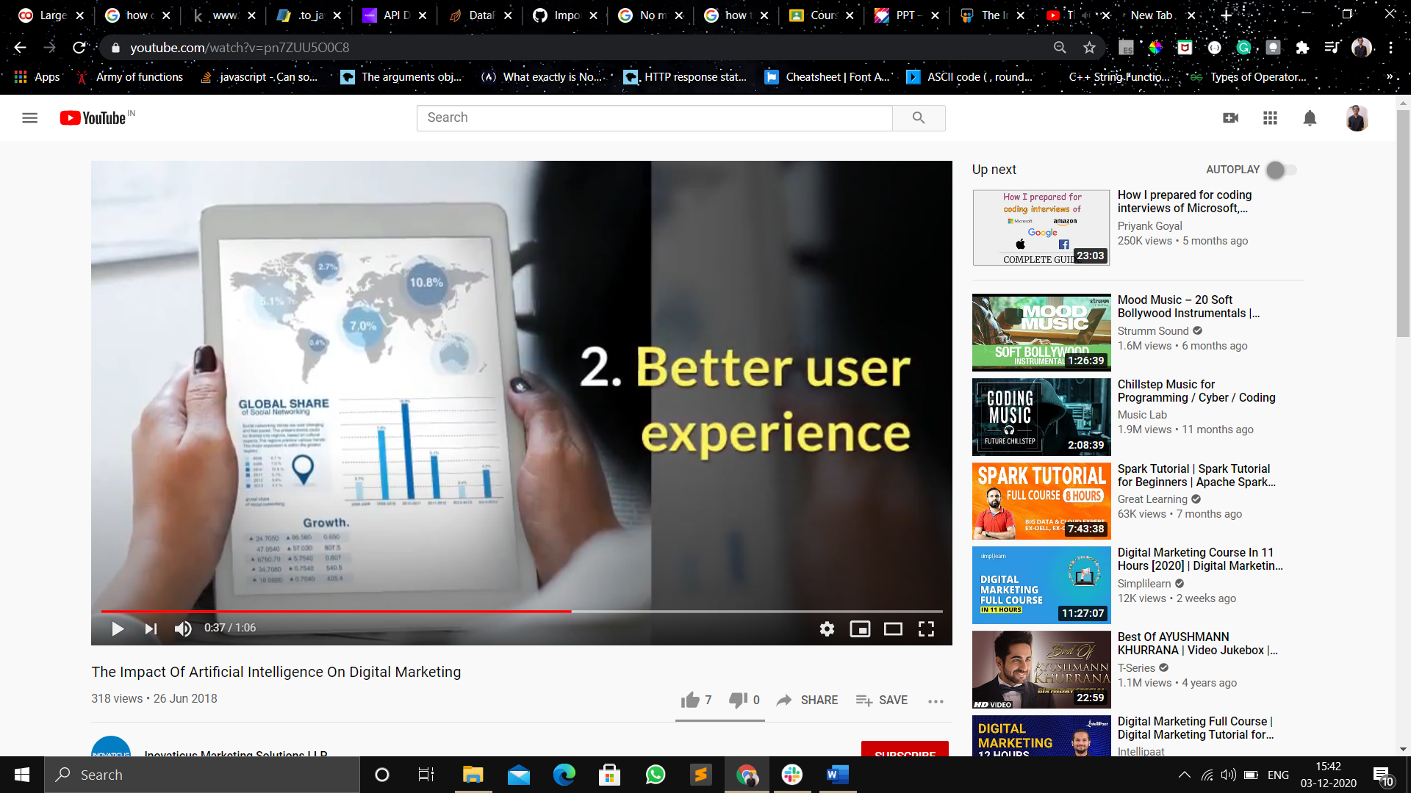

2.Better user experience

AI will enable you to understand the behaviour of the visitors to your website in a better way. This will enable you to visualize the buyer’s journey more accurately and create better funnels for improving sales. AI will have the power to give you customized recommendations to improve your website as well. All this will lead to the better user experience. All of these will enable you to provide a better user experience on your website and make your digital marketing efforts more effective

## **3.Create New Revenue Streams**

**Digital marketing in the modern era is all about data**. Due to the huge amounts of data available, it’s increasingly common to see marketing become the priority for many companies, as it has a direct link to increasing revenue.

{Example:---}The retail giant, Amazon, has harnessed the power of machine learning quite unlike any other, with [35%](https://www.martechadvisor.com/articles/customer-experience-2/recommendation-engines-how-amazon-and-netflix-are-winning-the-personalization-battle/) of their annual revenue generated through personalized product recommendations. Their cloud computing service, Amazon Web Services (AWS), provides opportunities for other companies to [benefit from AI](http://www.businessinsider.com/machine-learning-driving-innovation-at-amazon-2017-4) by using data insights to tailor their services to the customers’ needs. This in turn, will allow Amazon to gain additional revenue streams in innovative, new market areas.

## **4.Reduce ‘Marketing Waste**

When it comes to marketing, it is incredibly useful to have a system that can quickly identify trends and actions in real-time, and then respond accordingly without any human input. This ability to “learn” on the go is what makes machine learning so important in marketing today, and in the years to come.

## **5.Chatbots Engage Customers**

An increasingly common sight on many modern websites is the friendly chatbot that pops up in the bottom corner of the screen, offering assistance or advice soon after a visitor arrives on the site.

## **6.Improve Personalization**

People want brands to care about them. So much so, that 52%of customers are likely to switch brands if they don’t feel a company is making enough effort to personalize their messaging.

Amazon’s aforementioned success with e-commerce personalization is built upon machine learning. They harvest the huge reams of data on their customer’s online behaviors, interests, and past purchases to tailor the online shopping experience.

Everything from the emails to the product offers is personalized, along with every touchpoint in the buying journey.

***STEPS IN WHICH WE HAVE TO DEAL WITH DATA(As a Market)***

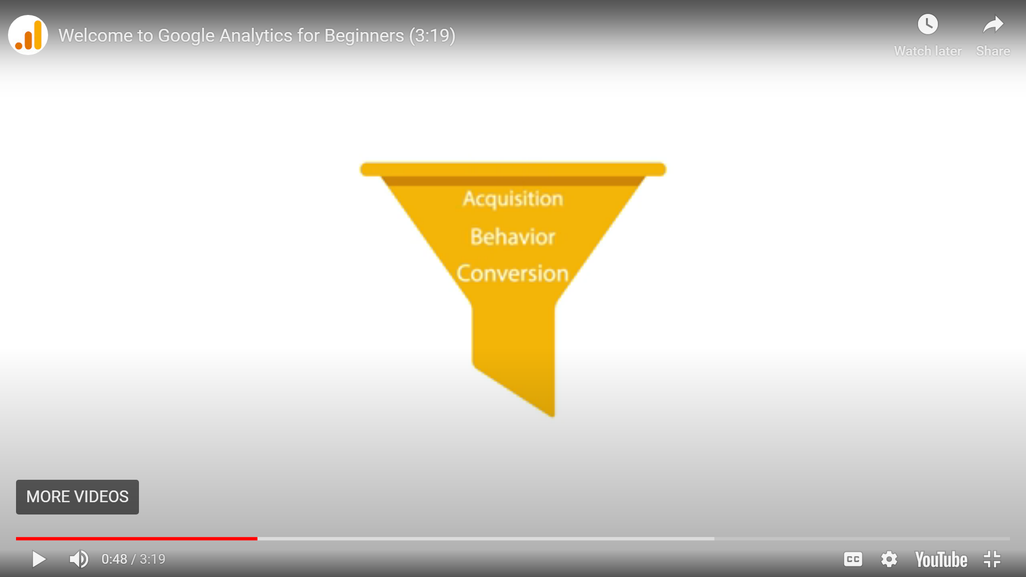

**1)Building awareness and acquiring user interest and Behaviour.**

**2)Behaviour : How user is engaging with your Business**

**3)When a user becomes a customer and transacts with your busines .**

***Role of AI in Digital Marketing :***

As a result of the advancements in various Machine Learning techniques, **Artificial Intelligence** (AI) has been playing a significant role in the field of **Digital Marketing**. A survey conducted by **Salesforce** showed that nearly **51% of the marketers are already using AI**, as of 2018. Many Marketers and Businesses have seen massive results by incorporating AI in their Digital Marketing Strategies. This led to Artificial Intelligence gaining more popularity in the recent years. So, it is safe to say that AI and Digital Marketing go hand-in-hand.

***Benefits of using Artificial Intelligence in Digital Marketing***

Using AI in Digital Marketing raises the level of productivity, since the processes are automated based on the instructions given. AI is also capable of understanding which content performs better and helps with content curation. As a result, the right content reaches the right audience, thereby increasing the ROI.

{FACTS}:

A study conducted by **Marketing Proofs** showed results that supported this fact. While surveying Businesses that implemented AI in their Marketing Strategies, they found that these Businesses had

* **59%**Better Closing Rates
* **58%**Increased Revenue
* **52%**More Conversions
* **54%** More Traffic and Engagement

These numbers convey the importance and necessity of using AI in Marketing.

## ***How to implement AI to improve your Digital Marketing Strategy?***

Since AI in Digital Marketing is growing drastically and will continue to do so, it is better to understand and implement it at the earliest to get a head start. Here are **some AI-based Digital Marketing Strategies** that can be implemented by Marketers and Businesses.

* **Website Builders powered by AI**

A website is considered to be a virtual office through which people can contact a Business and learn about their services. Having a full-functioning,designed website is highly essential for any Brand or Organization. In fact, a survey revealed that nearly **38% of the users stopped interacting with a website that was not designed well**. This shows the importance of having aresponsive and presentable website. However, building a website from scratch requires technical coding skills and can be time-consuming. That is why, Artificial Intelligence was introduced into the field of Web-designing through **AI-powered Website Builders**, to help people who lack the needed skills. These DIY builders require no technical knowledge and are easy to use. They ask a couple of questions to understand the user’s style and preferences and set up a neat website according to their requirements.

* **Chatbots**

A Chatbot is an **Artificial Intelligence Software Tool** that can simulate a human conversation through pre-defined sentences and phrases. Chatbots were initially designed to be interactive, by responding to trigger signals from the user. Nowadays, they are often used in **places that require very minimal interaction** and direct answers that address specific queries. This enhances the user’s experience by saving them time.

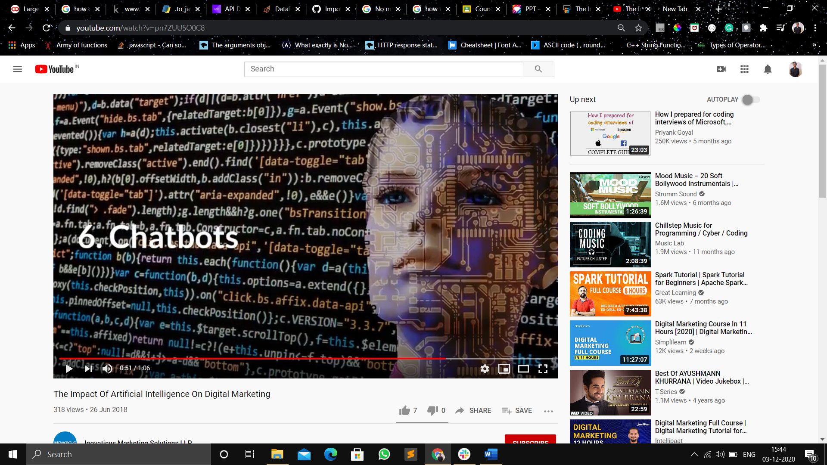

**Unsupervised Machine Learning role in Marketing:**

Machine learning in sales and marketing is an efficient way to find out more information about the customer and target them as best as possible. There are countless examples of machine learning in marketing, specifically unsupervised. For instance, things like organizing and clustering data into unlabeled clusters is what makes unsupervised machine learning so unique.

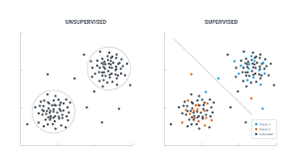

While supervised learning uses labels to put things in their place, unsupervised is more on its own and figures things out with much less data, effectively becoming a much more powerful tool. With it, companies can uncover trends that they would not have been able to catch otherwise.

Unsupervised learning is also often used for a variety of things like finding specific customers, catering to specific groups, and learning actionable customer insights.

## **Unsupervised Machine Learning Makes It Easier To Predict Stats and Behavior**

Predicting the future is nothing short of legendary. With unsupervised machine learning, data can be analyzed and clustered into organized sets of information without any prior labeling, giving companies insights they need.

## **Unsupervised Machine Learning Helps Prioritize Ad Targeting Through Segmentation**

Ad targeting a very big part of what makes ML in marketing so great; you can use it to cater to specific customers who are more likely to covert. By ensuring your audience receives ads and content that they actually want to see and interact with, ad targeting functions as the next best thing to reading minds, and unsupervised learning can make it even stronger through segmentation.

## **Unsupervised Machine Learning Improves The Customer Experience**

Without customer insights, your marketing and ad creation efforts would be solely based on guessing. Machine learning for brands, specifically unsupervised, is essential to organizing data into groups based on what a customer is like and what they interact with, as well as figuring out how to interact and further your relationship with them.

## **Key Takeaways for Marketers**

This technology is so much more. Four out of 10 marketers are already using machine learning to personalize their campaigns, according to this[exclusive report](https://www.martechadvisor.com/news/machine-learning-ai/evergage-study-reveals-88-marketers-deploy-personalization-to-improve-customer-experiences/?zd_source=mta&zd_campaign=12775&zd_term=chiradeepbasumallick), and this number will increase by 42 percent by next year.

**Now the key take away from this session is over reaching frame work how artificial intelligence can impact your organisation.**

**Research by**

**Apoorv**